Sedation Cheat Sheet

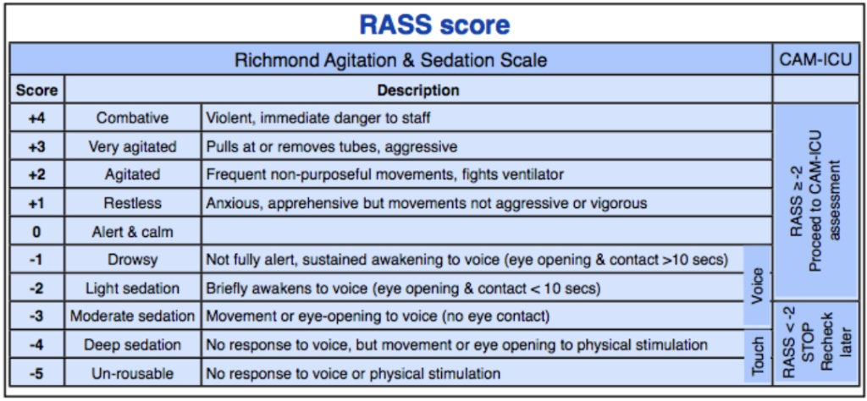
Image courtesy of Intensive Blog: https://intensiveblog.com/five-tips-for-icu-sedation/

Behavioural Pain Score
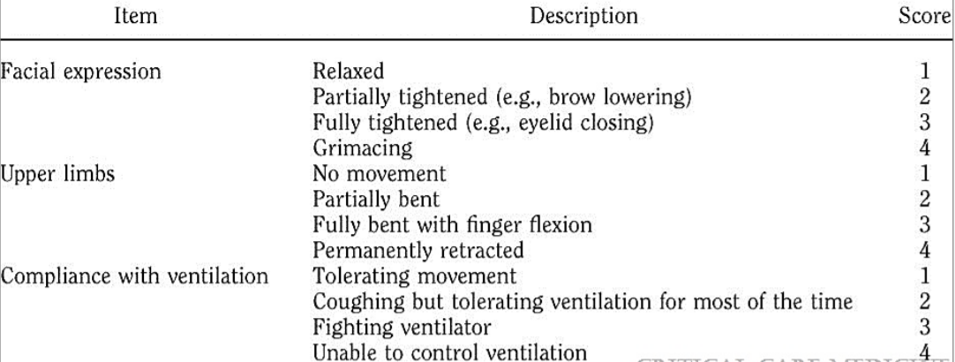
Bosson et al. Assessing pain in critically ill sedated patients by using a behavioural pain scal. Crit Care Med. 2001;29(12)2258-2263

Delirium Screen
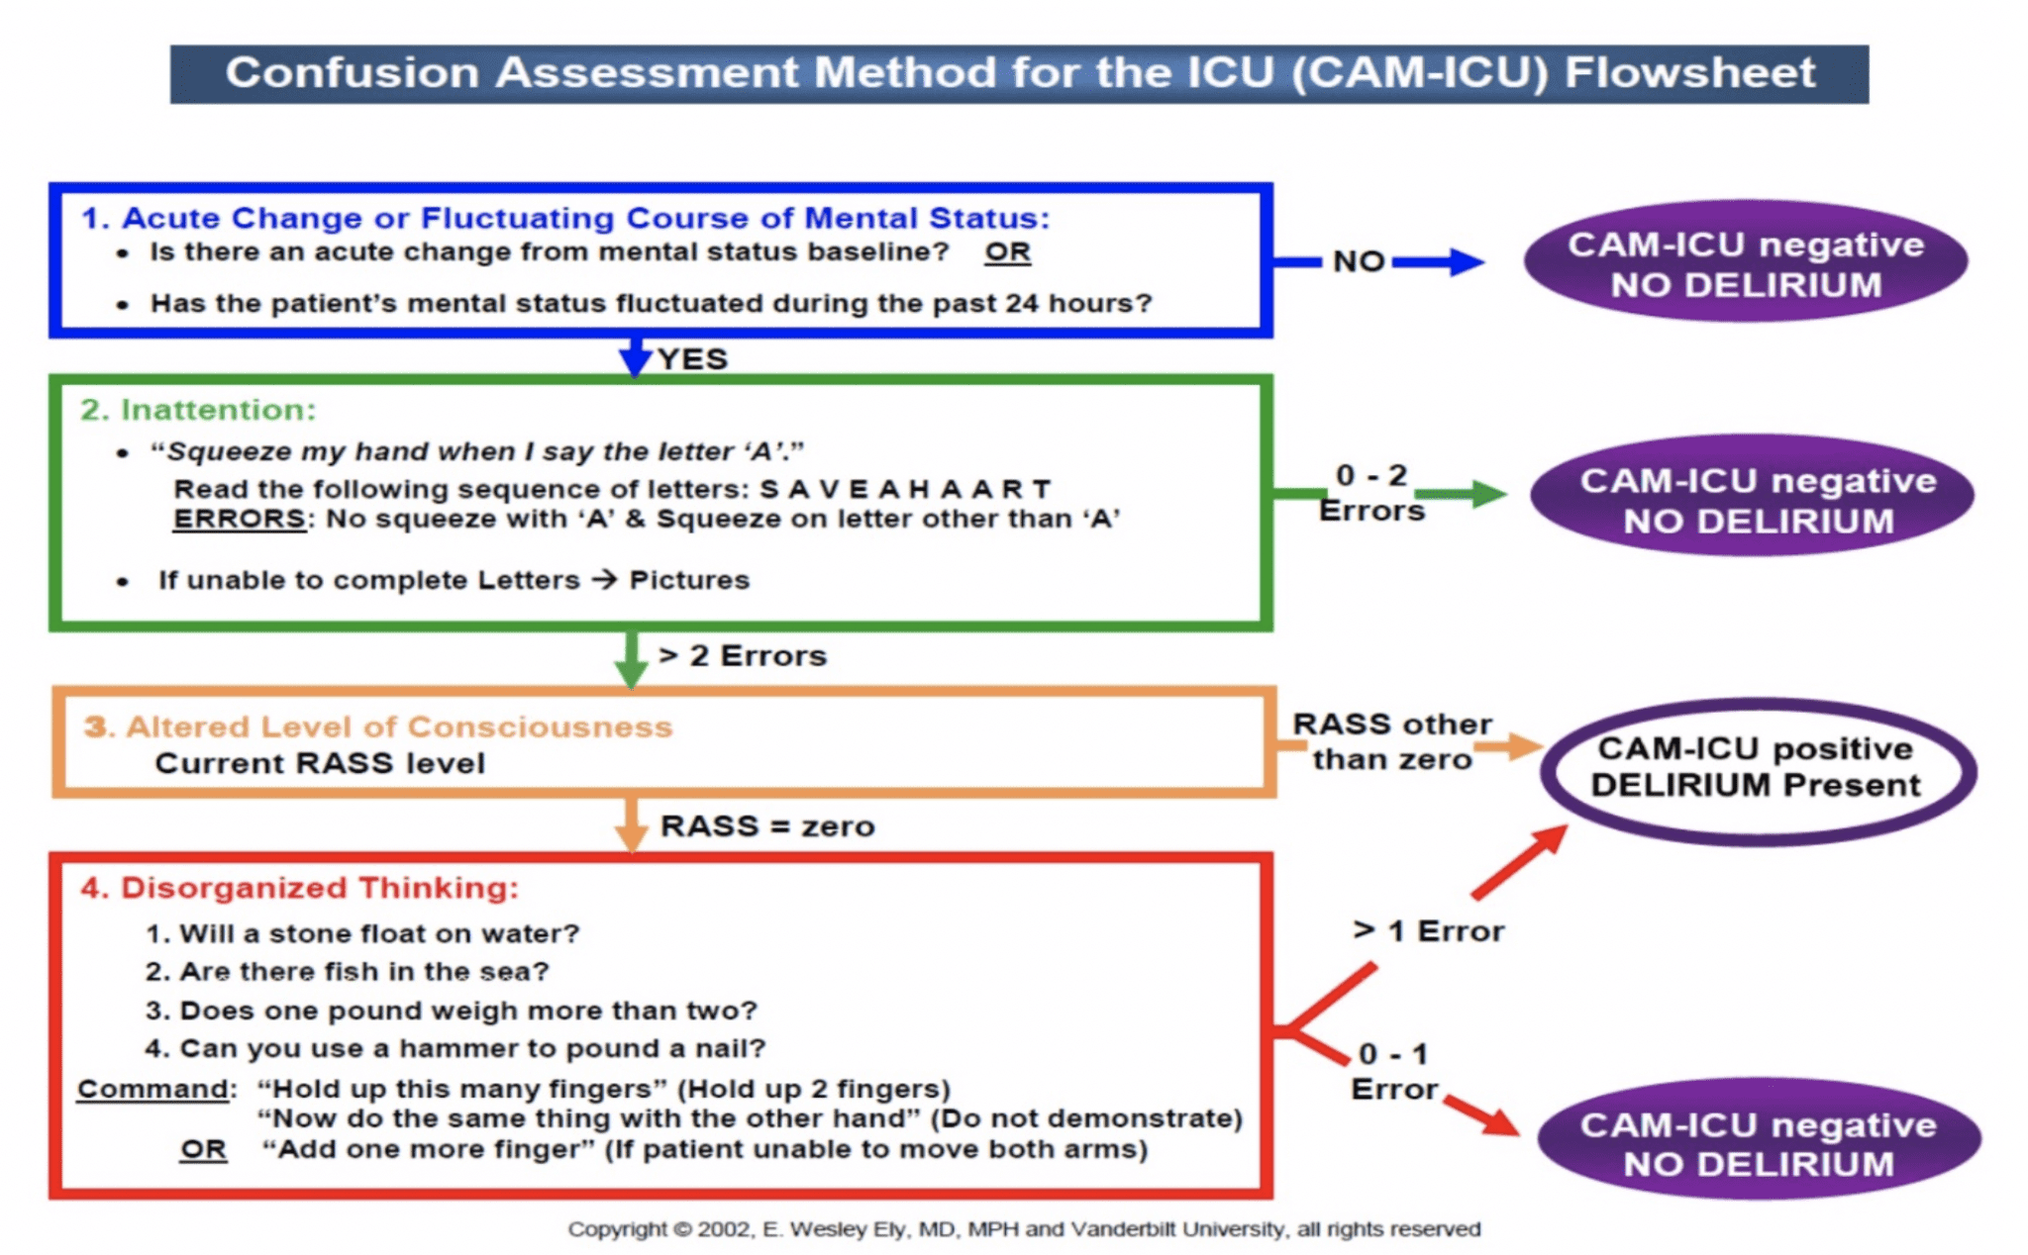
Image courtesy of REBELEM Blog: https://rebelem.com/delirium-in-critical-illness-haloperidol-vs-ziprasidone/

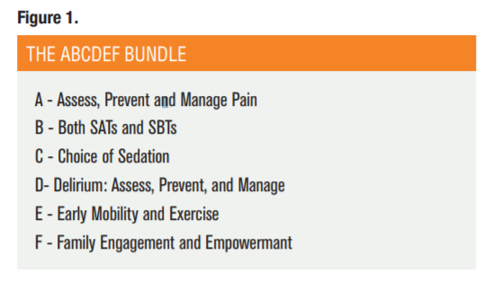
Marra, Annachiara et al. “The ABCDEF Bundle in Critical Care.” Critical care clinics vol. 33,2 (2017): 225-243. doi:10.1016/j.ccc.2016.12.005

